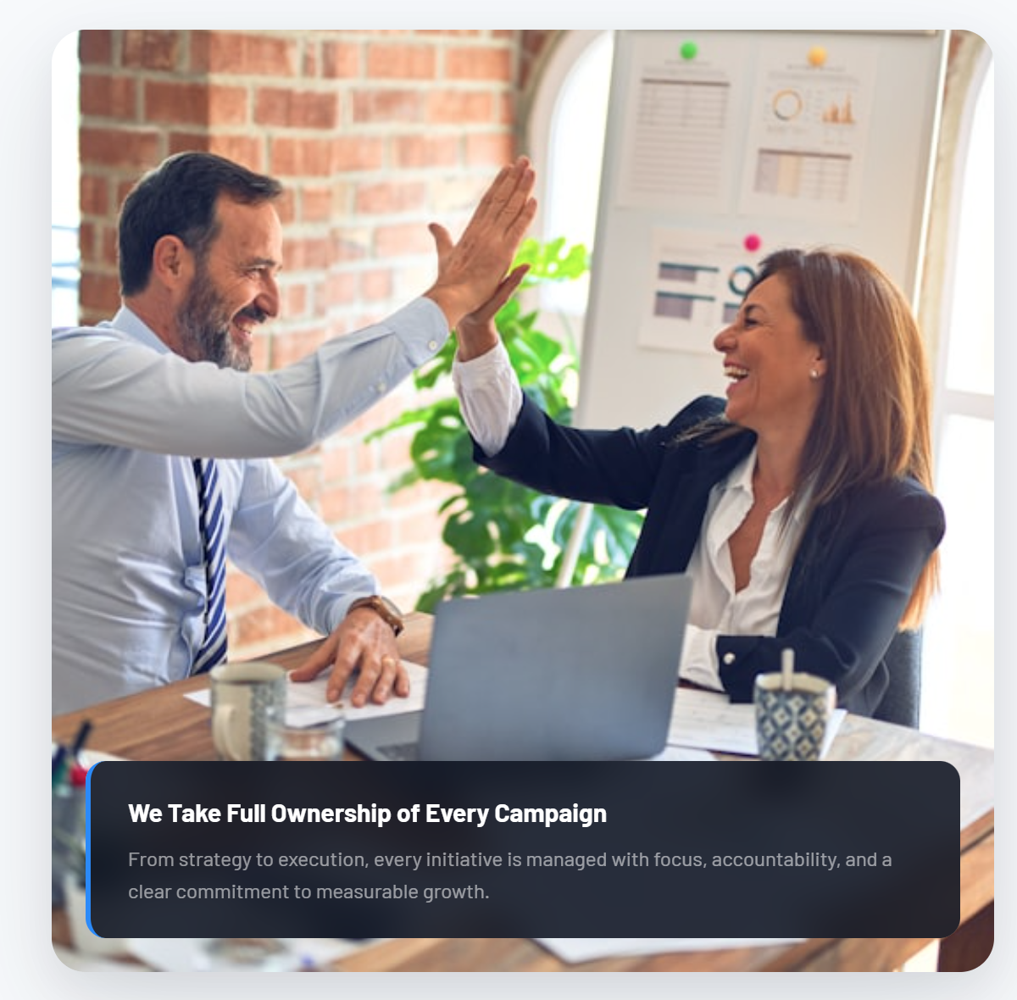
Current text is too long still. Below is shorter:

Where Strategy Meets Growth
Clear execution designed to support measurable business growth.

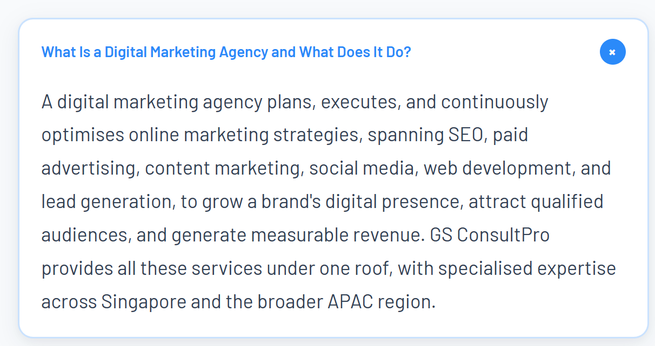
Remove this question. Are we not saying that we do more than digital marketing. So, why is this question included?
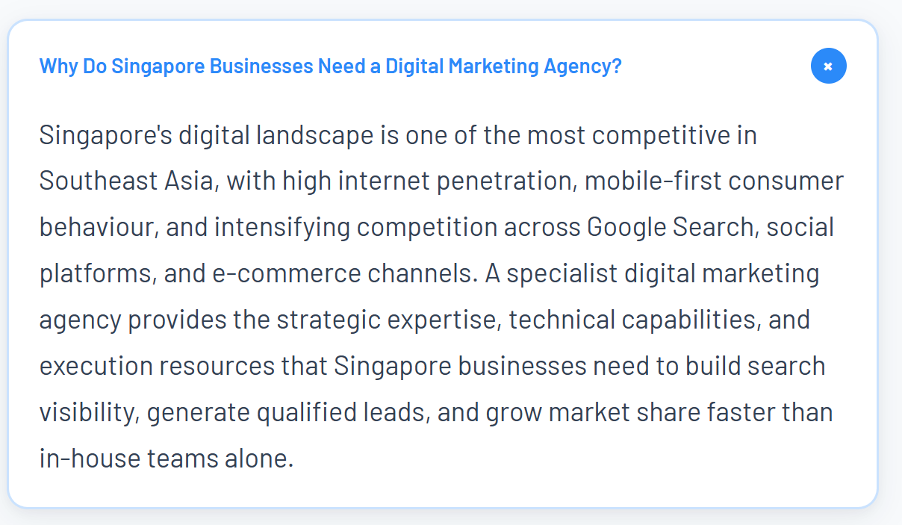
Why Do Businesses Need Digital Marketing and Growth Support?
Businesses today need more than isolated marketing campaigns. They need integrated strategy, digital execution, automation, and market engagement to strengthen visibility, generate demand, and compete effectively in increasingly crowded markets.
GS ConsultPRO helps businesses across Singapore and APAC combine growth strategy, digital platforms, content, automation, and execution to support measurable and scalable growth.

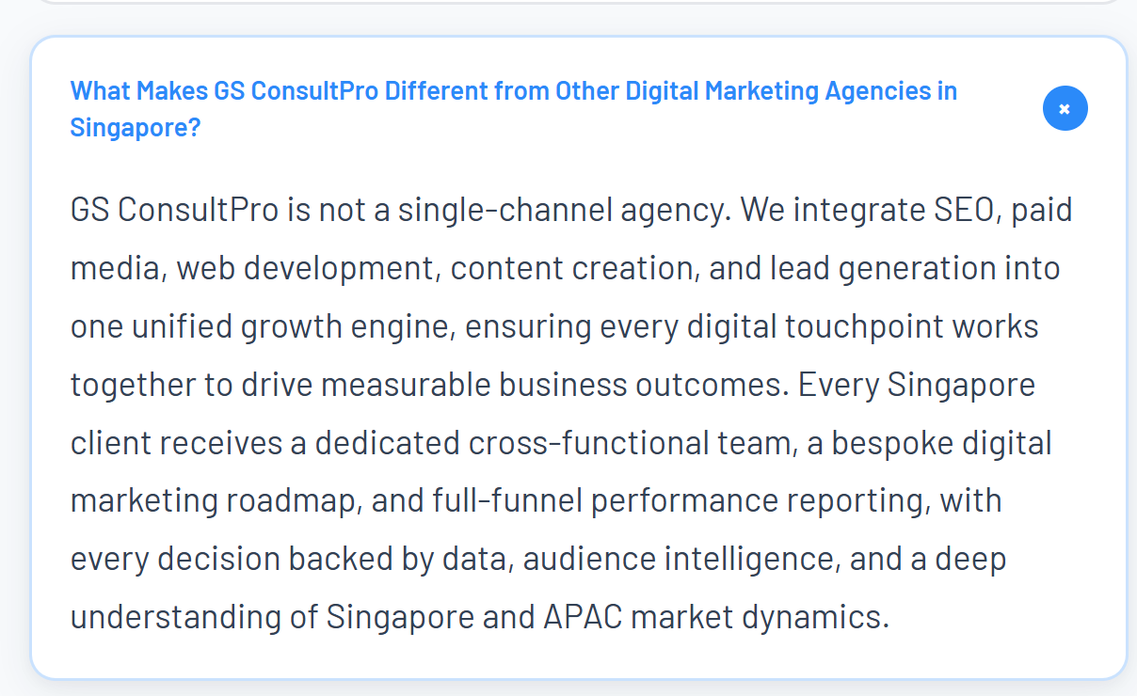
Did we not discuss this thing on last call. It can’t be categorized only as a digital marketing agency.

What Makes GS ConsultPRO Different?
GS ConsultPRO combines strategy, digital execution, automation, and market engagement to help businesses build visibility, generate demand, and support measurable growth across Singapore and APAC.
Rather than focusing on isolated campaigns, we align SEO, content, digital platforms, paid media, and growth initiatives around clear business objectives and measurable outcomes.

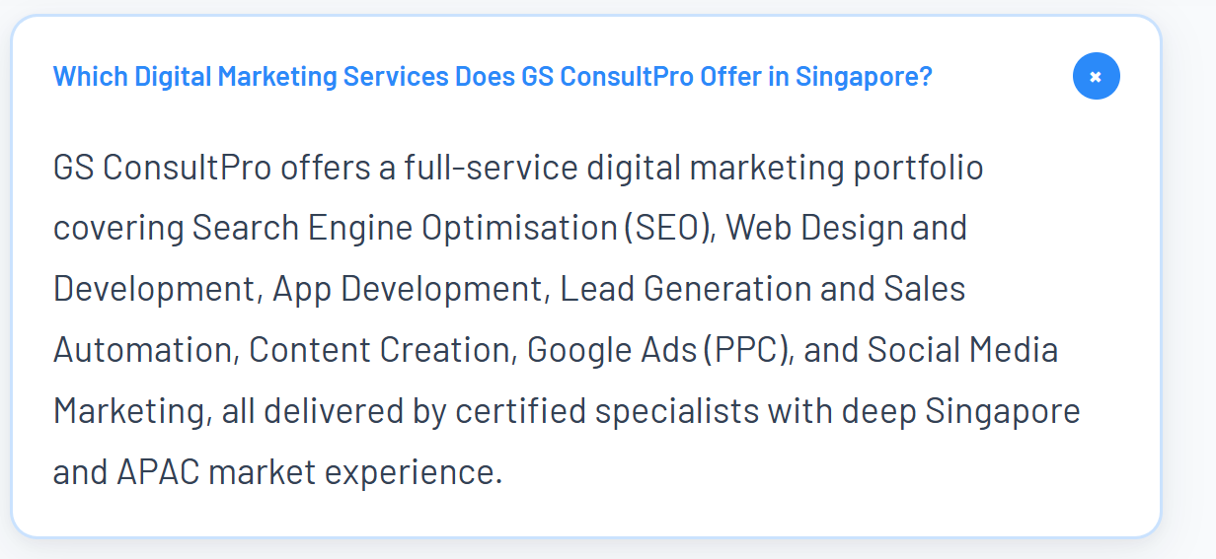
Remove the above.

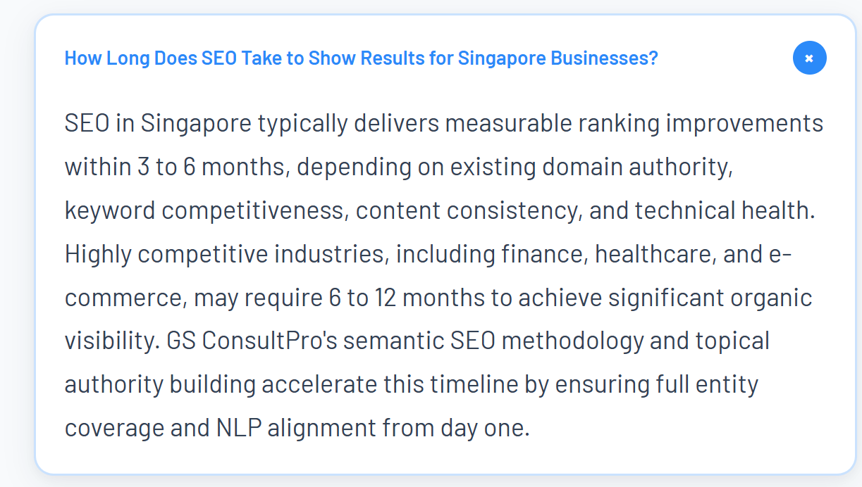
Why have we included healthcare. Do we mention anywhere healthcare is one of the target industries. These seem like standard answers that are being provided without paying attention to what GS ConsultPRO is doing.
How Long Does SEO Take to Show Results?
SEO typically delivers measurable improvements within 3 to 6 months, depending on factors such as competition, website authority, technical performance, and content consistency. More competitive industries may require longer-term investment to achieve strong organic visibility and sustainable ranking growth.
GS ConsultPRO focuses on structured SEO strategies designed to strengthen search visibility, build topical authority, and support long-term business growth.

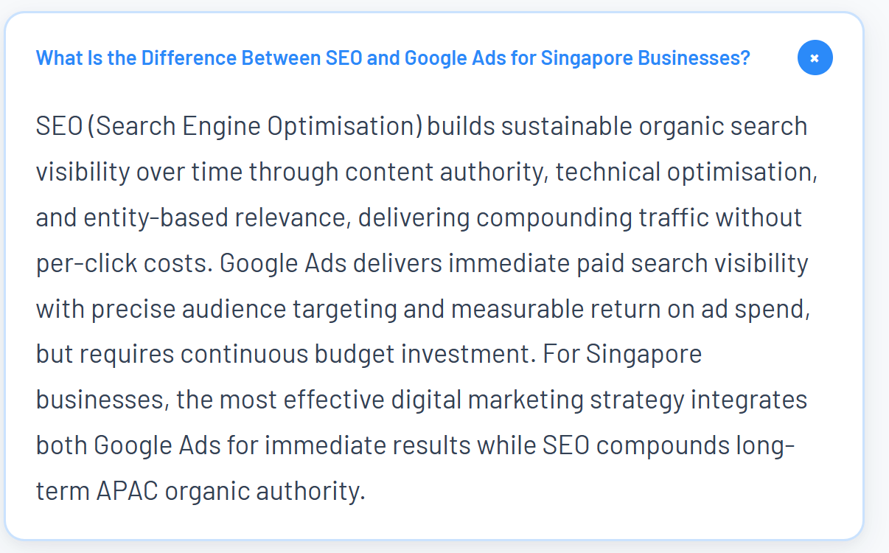
What Is the Difference Between SEO and Google Ads for Businesses?
SEO (Search Engine Optimisation) builds long-term organic visibility through content strategy, technical optimisation, and search authority, helping businesses generate sustainable traffic and reduce long-term acquisition costs.
Google Ads provides immediate paid search visibility, targeted traffic, and measurable lead generation through ongoing advertising campaigns.
For many businesses, the strongest digital growth strategy combines both SEO for sustainable long-term visibility and Google Ads for immediate traffic, conversions, and demand generation.

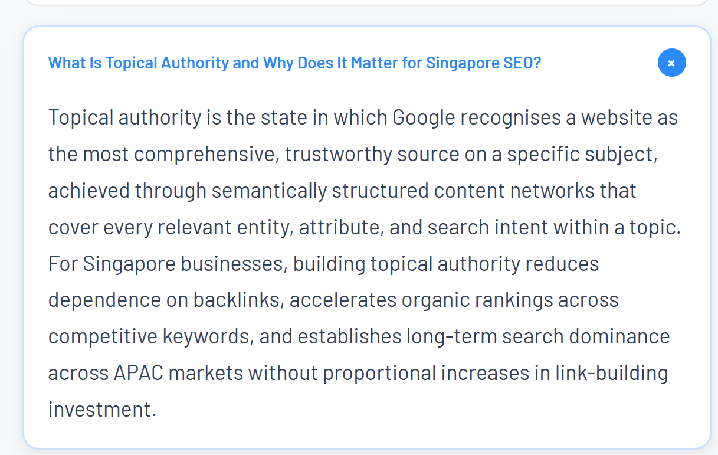

What Is Topical Authority and Why Does It Matter for SEO?
Topical authority is the process of building comprehensive, trusted expertise around a specific subject so search engines recognise a website as a credible source within that area.
This is achieved through strategically structured content that covers related topics, search intent, user questions, and key subject areas in depth.
For businesses, strong topical authority improves organic visibility, strengthens rankings across competitive keywords, reduces dependence on paid traffic, and supports long-term SEO growth
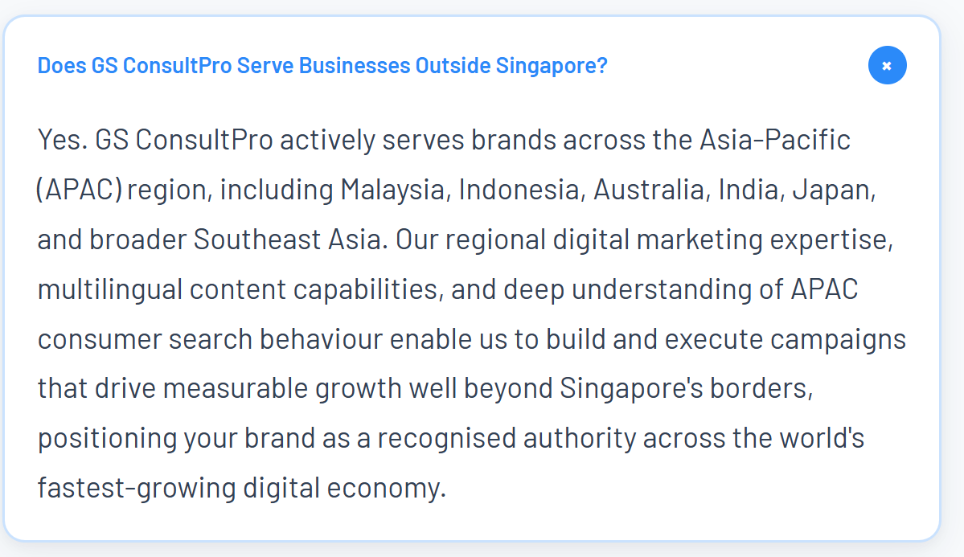
Yes. GS ConsultPRO supports businesses across APAC, including Southeast Asia, Malaysia, Indonesia, Thailand, Vietnam, Cambodia, India, and other regional markets.
Our experience across APAC helps businesses adapt strategy, content, digital execution, and growth initiatives for regional audiences, market conditions, and local business environments.
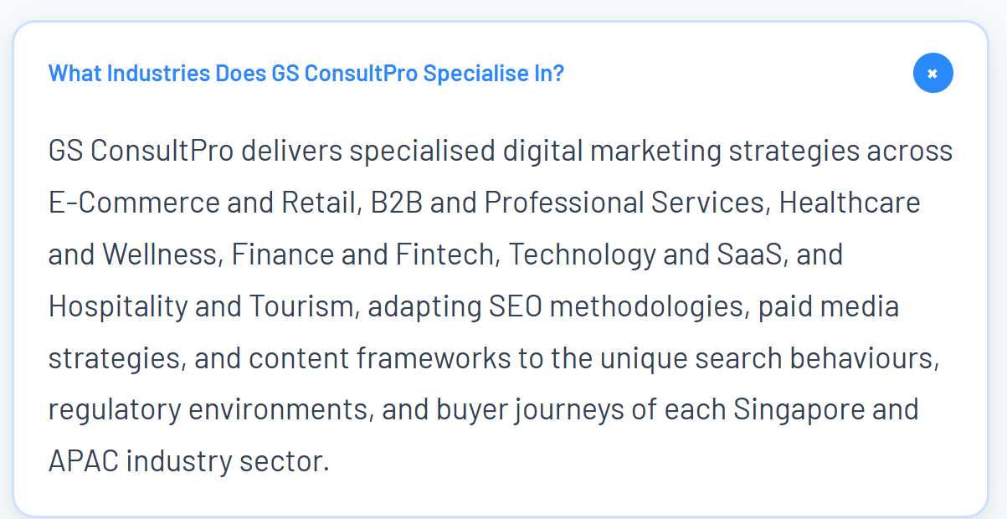

This creates a positioning mismatch with the rest of the website. Our “Industries We Focus On” section is intentionally focused on:
- Financial Services & Fintech
- SaaS & Technology
- Professional Services
But this FAQ suddenly expands into E-Commerce, Retail, Healthcare, Hospitality, and Tourism, which makes the brand feel much broader and more template-driven than the positioning we are building for GS ConsultPRO.
If this content was written specifically for GS ConsultPRO, these inconsistencies should have been identified and aligned with the actual strategic direction of the website. At the moment, it reads more like a generic digital marketing agency template rather than focused positioning tailored to our target markets and services.

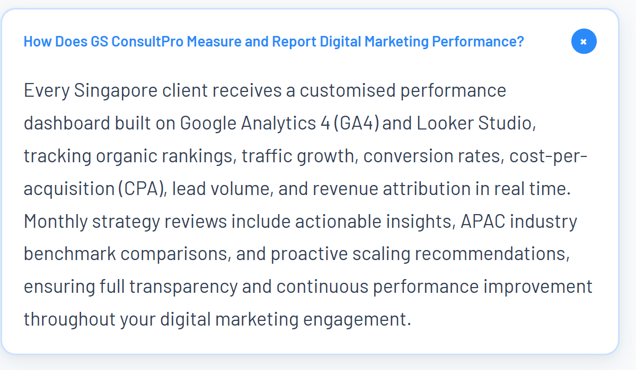
How Does GS ConsultPRO Measure and Report Performance?
GS ConsultPRO provides customised reporting dashboards using platforms such as Google Analytics 4 (GA4) and Looker Studio to track visibility, traffic, engagement, lead generation, and conversion performance.
Regular strategy reviews and performance reporting help businesses understand what is working, identify growth opportunities, and make informed marketing and digital growth decisions.

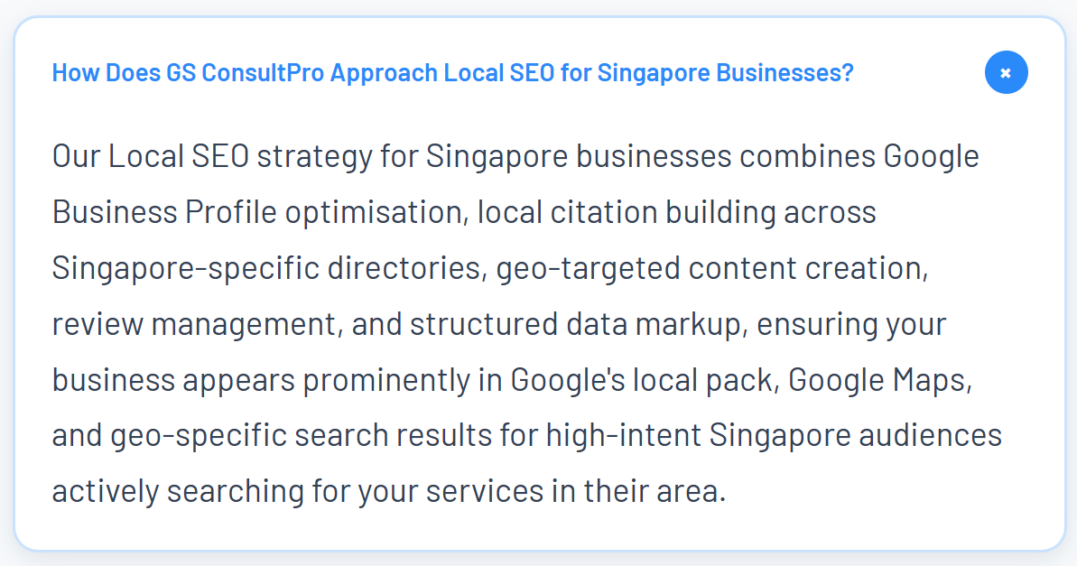
How Does GS ConsultPRO Approach Local SEO?
Our Local SEO strategies help businesses improve visibility across Google Search, Google Maps, and location-based search results.
This includes Google Business Profile optimisation, local citation building, geo-targeted content, review management, and structured data implementation designed to strengthen local search visibility and attract high-intent audiences actively searching for relevant services.

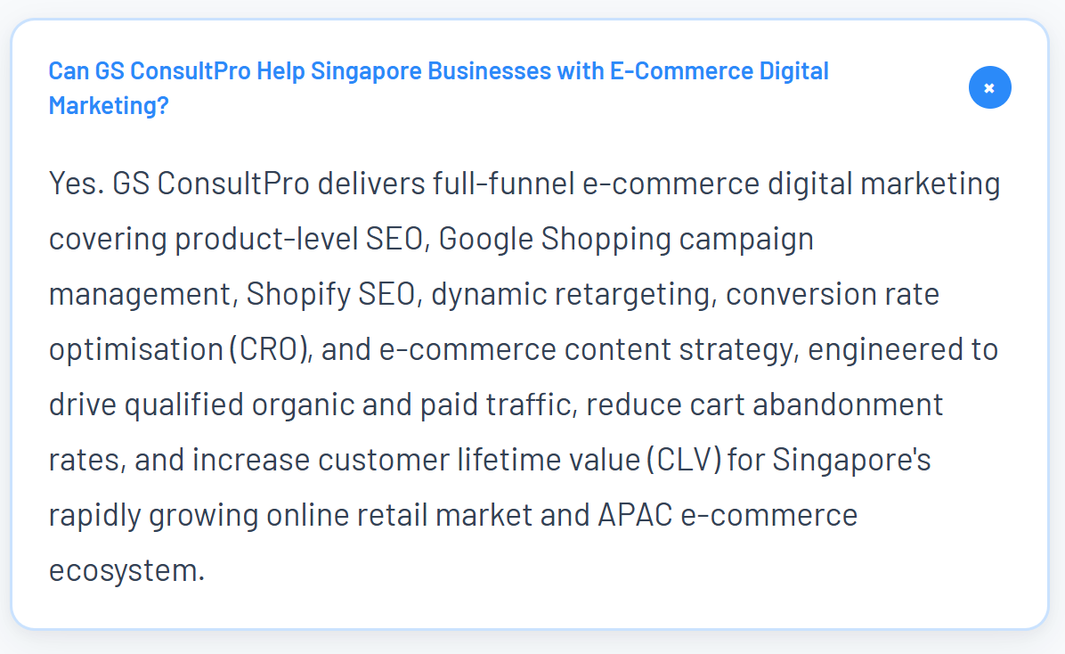
Remove this one. Adding a detailed e-commerce FAQ with terms like Shopify SEO, cart abandonment, CRO, and CLV makes the brand feel more like a generalist digital marketing agency rather than a focused regional growth consultancy.
It also introduces a large number of additional SEO keywords and service areas that are not currently reflected in the main industry positioning on the site.

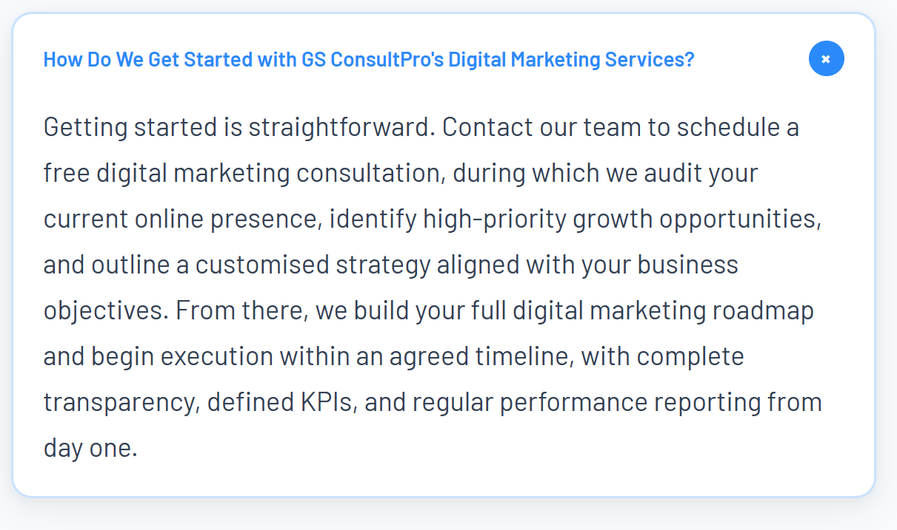
How Do We Get Started with GS ConsultPRO?
Getting started begins with a consultation to understand your business objectives, current digital presence, and growth priorities.
From there, GS ConsultPRO develops a tailored strategy and execution roadmap aligned with your goals, timelines, and measurable growth objectives.
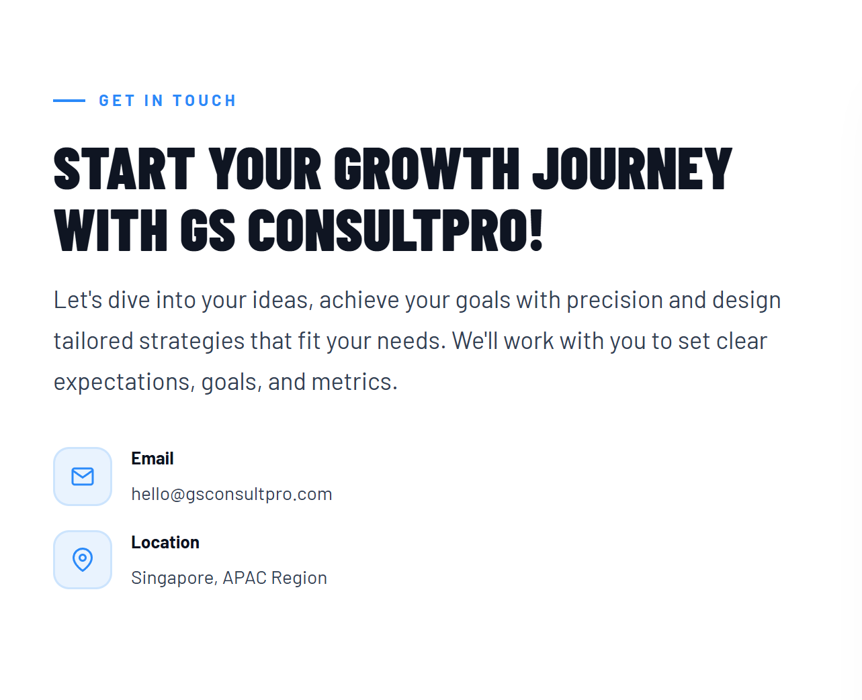
Headline:
LET’S BUILD YOUR NEXT STAGE OF GROWTH.
Body:
Growth-focused digital strategy, execution, and market engagement designed for businesses across Singapore and APAC.

Location
Singapore • Serving APAC
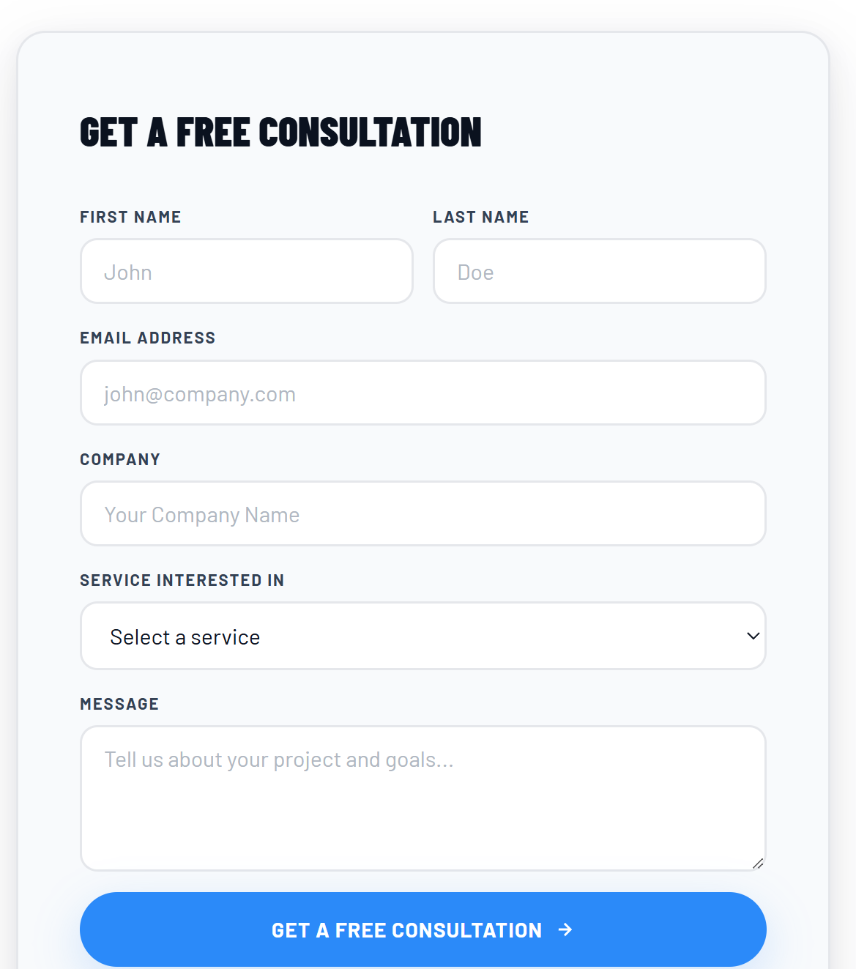
This form actually looks clean and premium visually. The biggest improvement I’d make is reducing repetition of “Free Consultation.”
Right now:
- headline says it
- button says it
That weakens the impact.
Headline:
GET IN TOUCH
Then keep the button:
GET A FREE CONSULTATION
That creates much better hierarchy.
Also:
“Service Interested In” could become: Services of Interest
And:
“Tell us about your project and goals...” could become:
- Tell us what you’re looking to achieve…
Small refinements, but they’ll make the whole form feel more custom and premium rather than standard agency-template UI.

